ACKNOWLEDGMENT

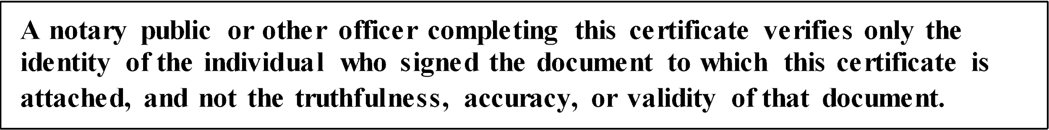

STATE OF _______________ )

) ss

COUNTY OF_______________ )

On _________________________ before me, ______________________________________,

personally appeared **_______________________________________**, who proved to me on the basis of satisfactory evidence to be the person(s) whose name(s) is/are subscribed to the within instrument and acknowledged to me that he/she/they executed the same in his/her/their authorized capacity(ies), and that by his/her/their signature(s) on the instrument the person(s), or the entity upon behalf of which the person(s) acted, executed the instrument.

I certify under PENALTY OF PERJURY under the laws of the State of ___________________ that the foregoing paragraph is true and correct.

WITNESS my hand and official seal.

Signature ______________________________ (seal)